**Electronics Gadgets – Task 2**



SELECT FirstName, LastName, Email FROM Customers;





select orders.orderid, orders.orderdate, customers.firstname, customers.lastname from orders join customers on orders.customerid=customers.customerid;

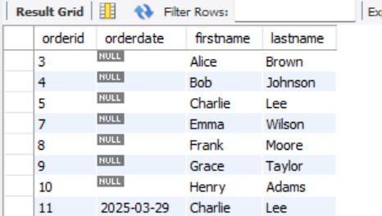



Insert into customers(firstname, lastname, email, address) values (‘Sandhya’, ‘Chandru’, ‘sandy@123’, ‘India’);



UPDATE products

SET Price = Price * 1.10

WHERE ProductName IN ('Laptop', 'Smartphone', 'Headphones', 'Keyboard', 'Mouse', 'Monitor', 'Printer', 'Tablet', 'Speakers', 'External HDD');



DELETE FROM OrderDetails WHERE OrderID = 5;

DELETE FROM Orders WHERE OrderID = 5;



INSERT INTO Orders (CustomerID, OrderDate, TotalAmount)

VALUES (5, '2025-03-29', 2200.00);

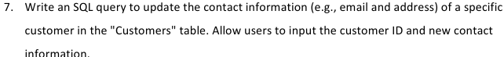

UPDATE Customers

SET Email = 'new.email@example.com',

Address = '789 New Street, Cityville'

WHERE CustomerID = 3;



UPDATE Orders o

SET o.TotalAmount = (

SELECT SUM(od.Quantity * p.Price)

FROM OrderDetails od

JOIN Products p ON od.ProductID = p.ProductID

WHERE od.OrderID = o.OrderID

);

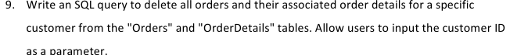

Delete From OrderDetails

Where OrderID IN (Select OrderID FROM Orders Where CustomerID = 5);

Delete From Orders

Where CustomerID = 5;



INSERT INTO Products (ProductName, Description, Price, StockQuantity)

VALUES ('Smartwatch', 'Advanced smartwatch with fitness tracking', 250.00, 50);



ALTER TABLE Orders ADD COLUMN Status VARCHAR(20) DEFAULT 'Pending';

UPDATE Orders

SET Status = 'Shipped'

WHERE OrderID = 3;



ALTER TABLE Customers ADD COLUMN OrderCount INT DEFAULT 0;

UPDATE Customers c

SET c.OrderCount = (

SELECT COUNT(o.OrderID)

FROM Orders o

WHERE o.CustomerID = c.CustomerID

);